Name of Student Checking Binder ____________________
Name of Student whose binder is being checked_________________
Binder Check
Place a check mark if the paper is in the order below…
_____ Learning Goals & Scales Sheet
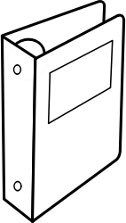
_____My Daily Learning Chart
_____Exit Ticket 1.1
_____Exit Ticket 1.2
_____Exit Ticket 1.3
_____Exit Ticket 1.4
_____Multiplication/Division Chart
_____Base 10 Chart (tenths, hundredths, etc…)
_____Let’s Be Rational Book
Classwork Tab
_____Problem 1.1
_____Problem 1.2
_____Problem 1.3
_____Labsheet 1.3 (Land Sections)
_____Problem 1.4
_____Labsheet 1.4 (Recipe Cards)
Homework Tab
_____Labsheet 1ACE (Exercise 27)

